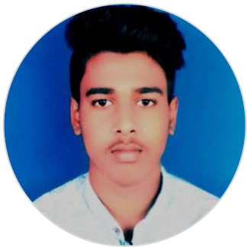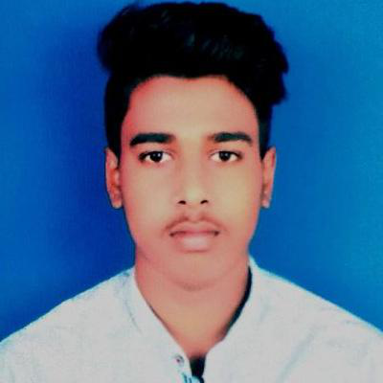

SATYAM SHIVAM

To enhance the performance of the company for better output through organized and progressive ways

with my sincerity ,hardwork and engineering skills with having good problem solving skills

[shivamsatyam33@gmail.com](mailto:shivamsatyam33@gmail.com)  7903796630

|  |  |  |
| --- | --- | --- |
| Hajipur,Bihar, India  **EDUCATION** | [linkedin.com/in/satyam-shivam-ab18a81b2](https://www.linkedin.com/in/satyam-shivam-ab18a81b2)  **SKILLS** | |
| **Master of Technology** | good communicator | management skills |

Amrita Vishwa Vidyapeetham

|  |  |  |  |  |
| --- | --- | --- | --- | --- |
| *10/2021 - Present*, | *Coimbatore,TamilNadu* | ability to perform under pressure | |  | | --- | | adaptability | |
| **Bachelor of Technology** |  | |  | | --- | | problem solving | |  |

Nalanda College of Engineering

|  |  |  |
| --- | --- | --- |
| *08/2017 - 10/2021*, | *Nalanda,Bihar* | **PERSONAL PROJECTS** |
| *CGPA* |
| 7.62/10 |

Pollution Control-Contribution of Mechanical

|  |  |
| --- | --- |
| **Intermediate** | Engineering towards Environment (07/2021 - 08/2021) |

J.M.R. College

|  |  |  |
| --- | --- | --- |
| *05/2015 - 02/2017*, | *Vaishali,Bihar* | **INTERNSHIPS** |
| *Percentage* |
| 64.4% |

IIT KANPUR (06/2020 - 07/2020)

|  |  |
| --- | --- |
| **Matriculation** | *Programming in C* |

K.V.Hajipur

|  |  |  |
| --- | --- | --- |
| *04/2014 - 03/2015*, | *Vaishali,Bihar* | **CERTIFICATIONS** |
| *CGPA* |
| 9/10 | AUTOCAD (07/2019 - 08/2019) |

**LANGUAGES**

ENGLISH HINDI

*Full Professional Proficiency*  *Full Professional Proficiency*

**INTERESTS**

|  |  |  |  |  |  |  |
| --- | --- | --- | --- | --- | --- | --- |
| MUSIC | |  | | --- | | SPORTS | | |  | | --- | | TRAVELLING | | |  | | --- | | READING | |

|  |  |
| --- | --- |
| |  | | --- | | WRITING | |